|  |
| --- |
| **SharePoint 2013 Picture Editor App** |
|  |

This sample demonstrates an app for SharePoint that uses HTML5 to allow the user to select, edit, and save images in a SharePoint Picture library.

**Provided by:** Vivek Soni,   [Microsoft Services Global Delivery](http://www.microsoft.com/india/msindia/msindia_aboutus_msgd.aspx)

This sample picture editor app enables you to select an image and perform basic image editing operations without using a standalone image editor.

* You can select an image from the parent site’s picture libraries, capture from the device’s webcam, or browse or drag an image file from the file system. The image can be saved to a picture library in the parent site, or can be downloaded locally.
* This app uses the new HTML5 capabilities for the **Canvas** to enable image editing operations such as drawing objects, changing the color palette, and adding image effects. HTML5 also supports client-side image renditions such as scaling and touch-enabled devices.
* The app attempts to read geolocation data from the image binary's Exchangeable image file format (Exif) record. If the host SharePoint picture library has a geolocation field, the data is saved there.
* The app also adds two custom actions and places them on the Edit Control Block (ECB) and in the Files tab in the ribbon on the parent site’s Picture libraries. These custom actions will start the app for the selected picture.

**C:\Users\nicg\AppData\Local\Temp\DxEditor\DduePreview\Default\d4fb9120-e4a9-420a-a374-31b6be443a1a\art\collapse.gifPrerequisites**

This sample app requires the following:

* Microsoft Visual Studio 2012
* Microsoft Office Developer Tools for Visual Studio 2012
* SharePoint Server 2013
* A team or publishing site with a Picture library (not a Document library). Optionally, the picture library should contain a geolocation field.
* An HTML5-compliant browser, such as Internet Explorer 10 (or later), Google Chrome, or FireFox.

**C:\Users\nicg\AppData\Local\Temp\DxEditor\DduePreview\Default\d4fb9120-e4a9-420a-a374-31b6be443a1a\art\collapse.gifKey components**

The sample app contains the following key components:

* The **Default.aspx** webpage, which is used to open, edit, and save images.
* The **scripts** folder, which contains several scripts that can be reused for other apps for SharePoint.
  + **SPPictureEditor_CanvasEditor.js** leverages the [Websanova Paint jQuery plug-in](http://jquer.in/jquery-plugins-for-html5-canvas/websanova-paint/), extended with additional tools.
  + **SPPictureEditor_AssetPicker.js**, **SPPictureEditor_FileBrowser.js**, **SPPictureEditor_DragDrop.js**, and **SPPictureEditor_Cam.js** provide the data sources from SharePoint, the browser, the file system, or the camera.
  + **SPPictureEditor_SPDataLibrary.js** loads and saves an image in a SharePoint site, and attempts to add the geolocation data.

**C:\Users\nicg\AppData\Local\Temp\DxEditor\DduePreview\Default\d4fb9120-e4a9-420a-a374-31b6be443a1a\art\collapse.gifBuild the sample**

Follow these steps to build the sample.

1. Press Ctrl+Shift+B to build the solution.
2. Press F5 to run the app.
3. If you are prompted by the browser, sign in to your SharePoint Server 2013 or Office 365 Enterprise site.

**C:\Users\nicg\AppData\Local\Temp\DxEditor\DduePreview\Default\d4fb9120-e4a9-420a-a374-31b6be443a1a\art\collapse.gifRun and test the sample**

1. Select one of the displayed image sources.  
   NOTE: Some HTML5 Web browsers do not support capturing Webcam devices, so the Device camera option will be disabled if you are using such as browser (for example Internet Explorer 10), or you may be notified that the feature is not supported (for example Firefox).

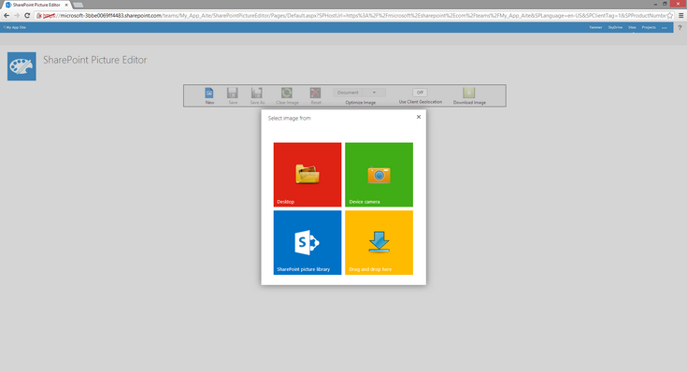

1. For example, by using the SharePoint asset picker you can browse and select an image file from any of the Picture libraries on the host site.

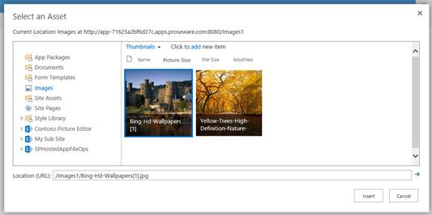

1. Use the HTML5 canvas editor to draw objects and lines, add text, and choose colors.

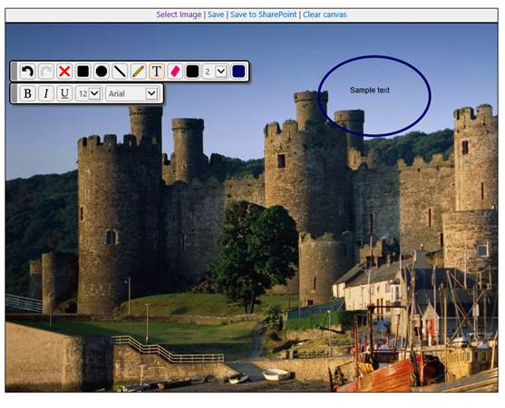

1. Save the edited image back to the source library or another picture library.

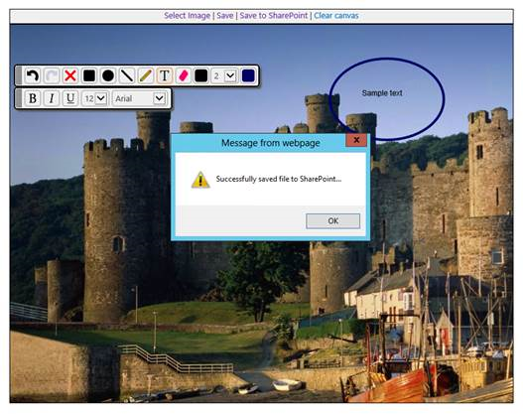

1. The app installs some custom actions on the host site’s Picture libraries for quick image selection.
   * In the Edit Control Block:  
       
     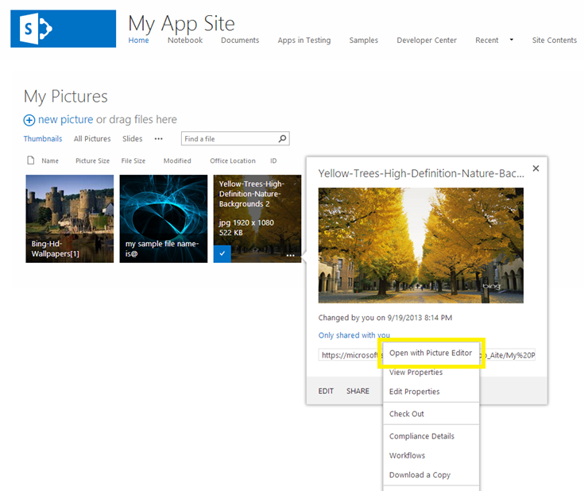
   * On the Picture library ribbon:  
       
     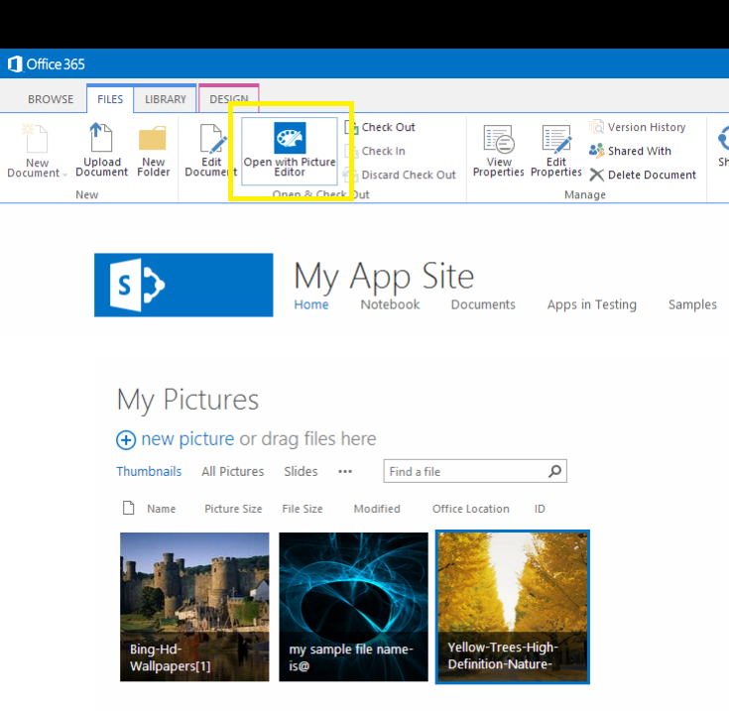

**C:\Users\nicg\AppData\Local\Temp\DxEditor\DduePreview\Default\d4fb9120-e4a9-420a-a374-31b6be443a1a\art\collapse.gifTroubleshooting**

Verify that you have access to a SharePoint site. Also, verify that you are using an HTML5-compliant browser.